Osnovna škola Podmurvice /Rijeka, Hrvatska/ predstavlja osobu koja nas nadahnjuje svojim pozitivnim primjerom:
književnica Ivana Brlić Mažuranić i njezin najpoznatiji lik šegrt Hlapić
Pozitivan lik? Tko nas nadahnjuje u našem užurbanom svijetu? Danas kao da i nema autoriteta i kao da se više nikome ne divimo? No ipak postoje neki ljudi koji su obilježili naš život…
Naš Comenius team dosjetio se poznate hrvatske književnice Ivane Brlić Mažuranić 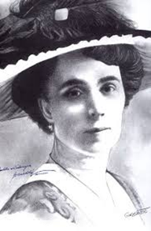 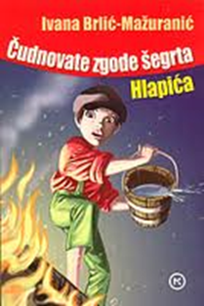
koja je naš uzor jer je bila prva žena koju je 1937. godine Akademija primila u svoje redove, napisala je mnoge divne bajke pa su je proglasili hrvatskim Andersenom, njezina su djela prevedena na sve značajnije svjetske jezike, a uz sve to bila je i ponosna majka petero djece za koje je i počela pisati priče.
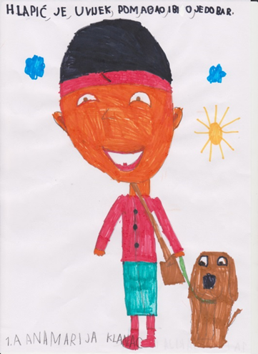
Njezin roman "Čudnovate zgode šegrta Hlapića" prvi put je objavljen 1913. godine i najobjavljivaniji je hrvatski roman uopće. Djelo je prevedeno na više desetaka jezika, među kojima su i dva izdanja na engleskom jeziku, tri na kineskom, osam na japanskom pa čak i izdanje na esperantu, dva bengalska izdanja, vijetnamsko, sedam slovenskih izdanja.
Što naše današnje generacije, sto godina nakon objavljivanja, misle o šegrtu Hlapiću pročitajte u nastavku.

Mladi knjižničari s voditeljicom Alidom Devčić Crnić

Sigurno se znate zapitati: „Kako da postanem bolji čovjek?“ To nam je pitanje postavila i najpoznatija hrvatska spisateljica Ivana Brlić-Mažuranić kada je odlučila napisati roman „Čudnovate zgode šegrta Hlapića“. Knjiga govori o pravim životnim vrijednostima, važnosti uzajamnog pomaganja i iskrenom prijateljstvu i dobroti.

Glavni lik, postolarski šegrt Hlapić, svojim nas postupcima uči kako da probleme ne rješavamo grubošću i nasiljem, već mirnim i staloženim ponašanjem. Ovo je knjiga neprolazne vrijednosti; ona obilježava naša djetinjstva i obogaćuje maštu.
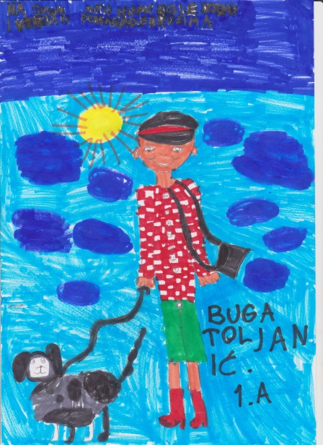
I sama je spisateljica bila snažna i odlučna žena, visokih moralnih i ljudskih vrijednosti koje je pretočila u sva svoja djela.
Godina 2013. vrlo je značajna jer se obilježava 100.-a obljetnica njezinog romana „Čudnovate zgode šegrta Hlapića“ te je tim povodom snimljen i istoimeni igrani film.

Hlapić je iskren prijatelj koji se žrtvuje za one koje voli. Učinio bi sve da svoju živahnu i nježnu prijateljicu Gitu zaštiti od zla koje prijeti u svijetu. Hlapićeva je duša nježna i topla, on je uvijek nasmijano, veselo dijete. Neki kažu da je i predobar, no baš nam takav dječji junak treba u današnjem užurbanom i agresivnom svijetu. U knjizi je Hlapićevo ponašanje opisano kao pravo dječje, iako osvaja ljubaznošću i osjetljivošću na nepravdu.
Požrtvovan je, nesebičan i spreman pomoći drugome bez da očekuje išta zauzvrat, a upravo su te osobine važne osobito danas u svijetu u kojem se prijateljstvo najčešće odvija preko zaslona računala.
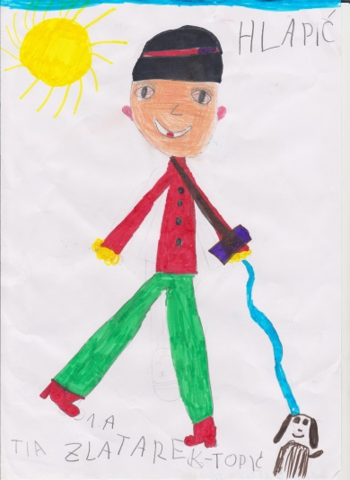

I zato, kada se ubuduće zapitate kako da postanete bolji, sjetite se Hlapića, dječaka „malenog kao lakat, veselog kao ptica, hrabrog kao kraljević Marko, mudrog kao knjiga i dobrog kao sunce“. Takvi nam junaci trebaju kako bi ovaj svijet uistinu postao ljepše i sretnije mjesto za sve ljude.
Marija Lanc, 11 godina

Volio je pomagati drugima u nevolji…a bio je siroče bez oca i majke…život kakav je imao Hlapić današnja djeca nemaju. Živimo puno ljepše i bogatije nego on. Ne moramo raditi da bi imali što jesti, imamo meke krevete za spavanje i nekoliko pari obuće i odjeće za nositi. Iako sve to imamo ponekad ne znamo to cijeniti. Često smo ljutiti i nezadovoljni za razliku od Hlapića koji je bio vedar i veseo dječak iako je živio u siromaštvu.
Hlapić nije birao kome će pomoći, a kome ne, svi su mu bili jednaki i svima je jednako pomagao. Mnoga djeca danas biraju prijatelje po boljim i skupljim mobitelima i tabletima ili nekim drugim skupim igračkama. Ne odabiru se prijatelji po dobroti i dobrim djelima. Dobri
postaju oni koji su jači ili oni koji se bolje znaju narugati drugima i koji do cilja dolaze lažima. Takva su djeca danas heroji.
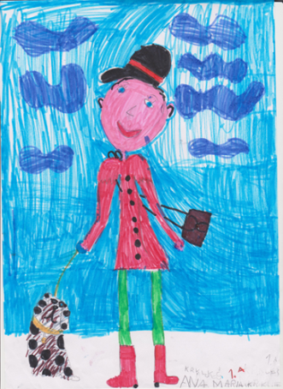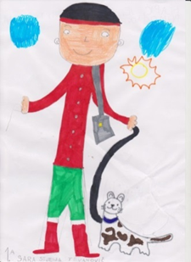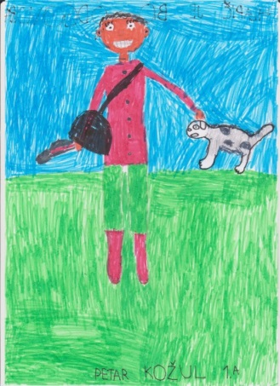
Crteže naslikali učenici 1. razreda koji imaju 7 godina.
Takav nije bio šegrt Hlapić, on se razlikuje od današnje djece. Hlapić je pokazao svojim djelima kako bi se svi ljudi trebali ponašati jer bi tako svima bilo ljepše i lakše živjeti. Pokazao je da i siromašan čovjek može biti sretan i zadovoljan. njegova dobrota, mudrost i hrabrost pomogli su mu u rješavanju prepreka na koje je nailazio.

Hlapić je sva svoja djela radio čistim srcem i bez nasilja pa je to glavni razlog po kojem se razlikuju od današnjih heroja.
Bilo bi lijepo da svako dijete, kad pročita „Čudnovate zgode šegrta Hlapića“, razvije bar neku od osobina koje je imao šegrt Hlapić.

Jana Krivošić, 9 godina
Podmurvice Elementary School /Rijeka, Croatia/ presents someone who inspires us by setting a positive example:
famous writer of children's tales Ivana Brlić Mažuranić and her famous book character Lapitch the apprentice

A positive character ? Who inspires us in the busy world we live in? It seems as if there was no authority, no one left to admire. Yet, there are some people who have left a mark in our lives...
Our Comenius team thought of the renowned Croatian author Ivana Brlić Mažuranić.
She is a role model to us for she was the first woman accepted as member of the Academy in 1937. She wrote many beautiful books of Croatian fairy tales ,
thus earning comparisons to Hans Christian Andersen. Apart from being a successful author whose works have been translated into many European languages, she was also the proud mother of five children, to whom she would read the stories that she wrote.
.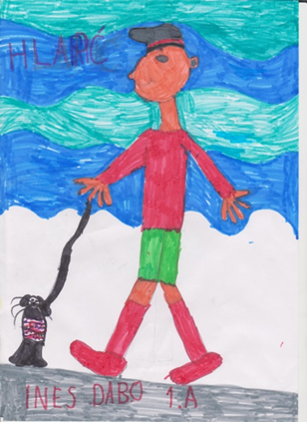
Drawings were made by first grade children, aged seven.

Her novel ''The Marvellous Adventures of Lapitch the Apprentice'', was first published in 1913 and remains Croatia's most printed novel of all time. The work was translated into dozens of foreign languages, among which, two editions in English, three in Chinese, eight in Japanese, as well as an edition in Esperanto and Vietnamese, two Bengali editions and seven Slovenian ones.
Please read below what today's generations, one hundred years after the publication of the novel, think about Lapitch the apprentice.

Young librarians under the guidance of Alida Devčić Crnić
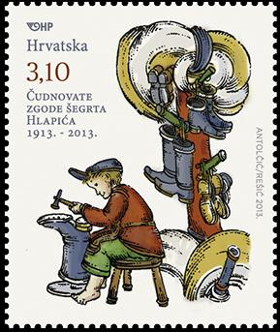 Stamp

Surely you sometimes ask yourself ,, How do I become a better person?'' Ivana Brlić-Mažuranić, the most famous Croatian female writer must have asked herself the same question when she decided to write ''The marvellous adventures of Lapitch the apprentice''. The book tells about real life values, the importance of mutual support, sincere friendship and kindness.

The main character, shoemaker Lapitch teaches us not to solve our problems with brutality or violence, but with a calm and peaceful behaviour. This is a book of eternal value; it marks our childhood and enriches the imagination.

The author herself was a strong and determined woman with high moral and human values, which she poured into her works. 2013 is a very important year because it marks the hundredth anniversary of her novel ''The marvellous adventures of Lapitch the apprentice'' which was made into a feature film.
Lapitch is an honest friend who sacrifices himself for those he loves. He would do anything to protect his gentle and lively friend Gita from the evil in the world. Lapitch's soul is gentle and warm. He is always happy and smiling.
Some say that he is too good a person, but he is exactly the child hero we need in today's fast paced and aggressive world. Lapitch's behaviour in the book is described as genuine child behaviour. He overwhelms us with his kindness and sensitivity to injustice.
He is devoted, unselfish and willing to help others without expecting anything in return. These personal traits are important in today's world where friendship is most often carried out on the screen of a computer.
Therefore, next time you ask yourself how to become a better person, remember Lapitch, a boy ''small as an elbow, merry as a bird, brave like princ Mark, wise as a book and good as the sun''. We need such heroes to make this world a better and happier place for all.
Marija Lanc, aged 11

He enjoyed helping people in distress...although he was an orphan without father or mother...children today do not have this kind of life. We live a much nicer life, we are richer than he was. We do not have to work in order to have something to eat. We have soft beds to sleep and many pairs of shoes and clothes to wear. Although we have it all, we sometimes don't know how to appreciate it. We are often angry or unhappy, unlike Lapitch, who was a bright and cheerful boy even though he lived in poverty.
Lapitch did not choose who to help. All were equal to him and he helped everyone equally. Many children today choose friends according to what mobile phone, tablet or other expensive toy another child has. They do not choose friends by kindness or good deeds. The strongest ones, those who mock other children and who attain goals by lying are considered as good children. It is this kind of children that are perceived as heroes today.

Lapitch was not like that. He was different from today's children. He showed us how people should behave in order for everyone to live a nicer and happier life. He also showed that even a poor person can be happy and satisfied. His kindness, wisdom and courage helped him in dealing with the obstacles which he encountered.

Lapitch did everything with a pure heart and without violence. This is the main reason why he is different from today's heroes.
It would be nice if every child, after reading ''The marvellous adventures of Lapitch the apprentice'', developed at least some of the qualities Lapitch possessed.

Jana Krivošić, aged 9

